How eBib was used as a Desktop-Software

TOC
Read Only End User Interface 1
Milestone 2 7
Index 7
Series: 7
Cross-References 9
Processes 9
Copyrights 11
File sharing among Scientologists 12
Files of the same Date 13

The images I show here are screenshots from my MS Access based Desktop application called eBib, which should be migrated to a web-app, i.e. Wordpress based. This document should not be understood as a detailed requirements specification, but just to give you the first insight into the existing DB and what it is used for.

eBib is the short name for „electronic Bibliography for Scientology related works“, which are mainly the works of L. Ron Hubbard and the Scientologists. We are talking about a Bibliography, which are desciptive data, giving all the attributes to a work. An example for a Bibliography could be the Index Cards of a library, one for each book or other medium (CD or DVD) in the library.

We are not related with the Church of Scientology in any way, but are a group of independend Users of the works of L. Ron Hubbard. We see his works as free and open source. The Church of Scientology sees his works as their monopoly and try to defend the copyrights, which revealed as impossible. The works spread are on millions of computers and not controllable any more.

The webbased software should help a growing community of independend Scientologists to organize the millions of files of L. Ron Hubbard's works: bulletings, books, articles, lectures, films and images.

Read Only End User Interface
You usually start with the list of WORKS:
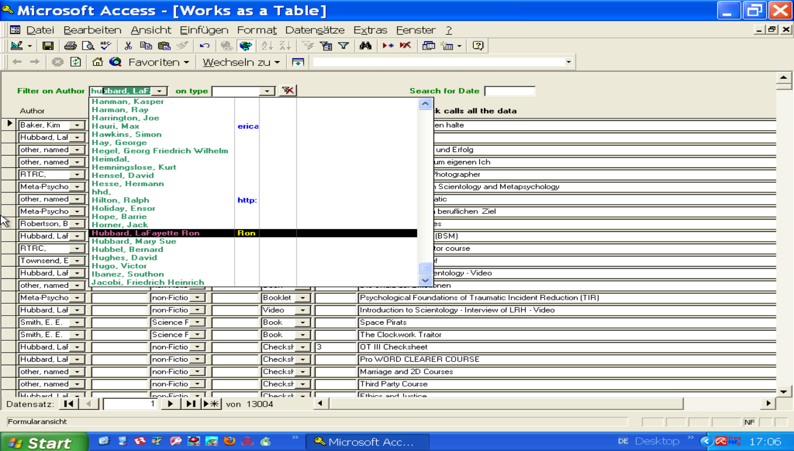
This list can be filtered by several fields. I have here only 3 fields to filter:
- Author
- Type
- Date
But in Web it should be possible to choose several fields:
- Author
- Type
- Date (also a range)
- Title (contains)
- Genre
The rows should be pure output fields in Web, not editable for the end user.
Call this page „Works Listing“

25 rows per page with pagination to scroll through the DB. A maximum of 50 rows for one filter, so that no one can harvest my DB so easily.

Here some images, how the selection in MS Access gets finer and finer:

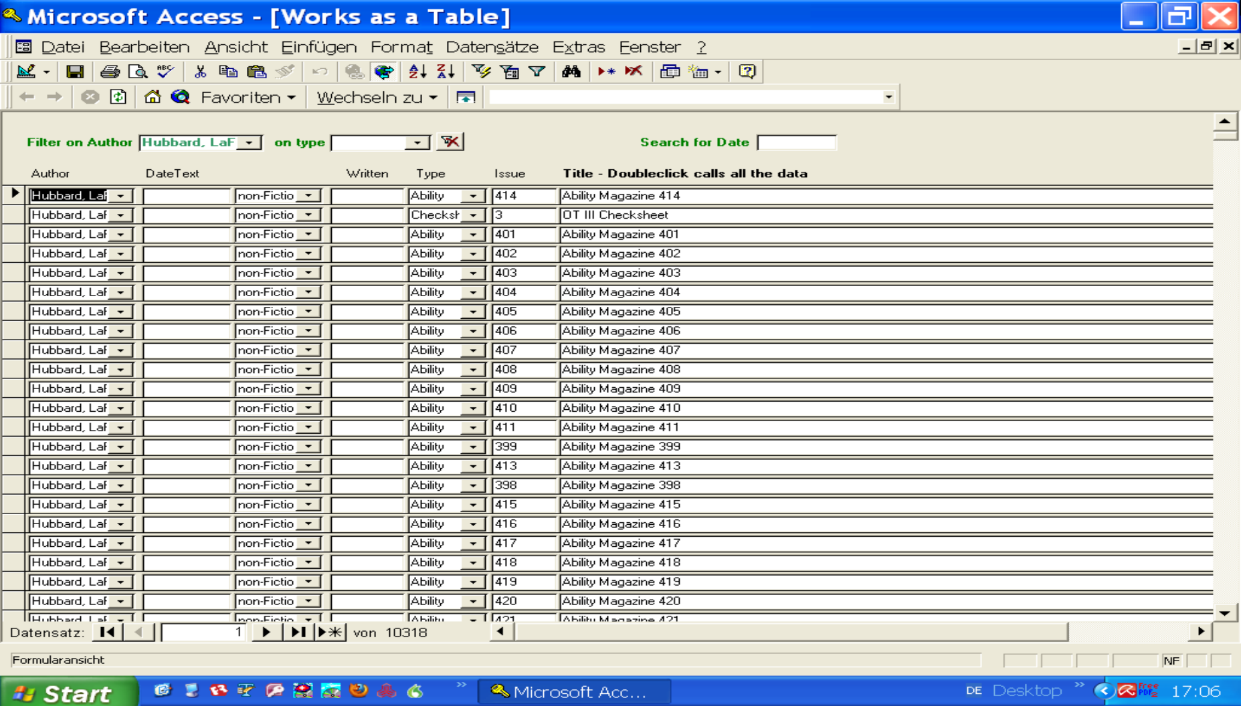
Filtered to one Author only.
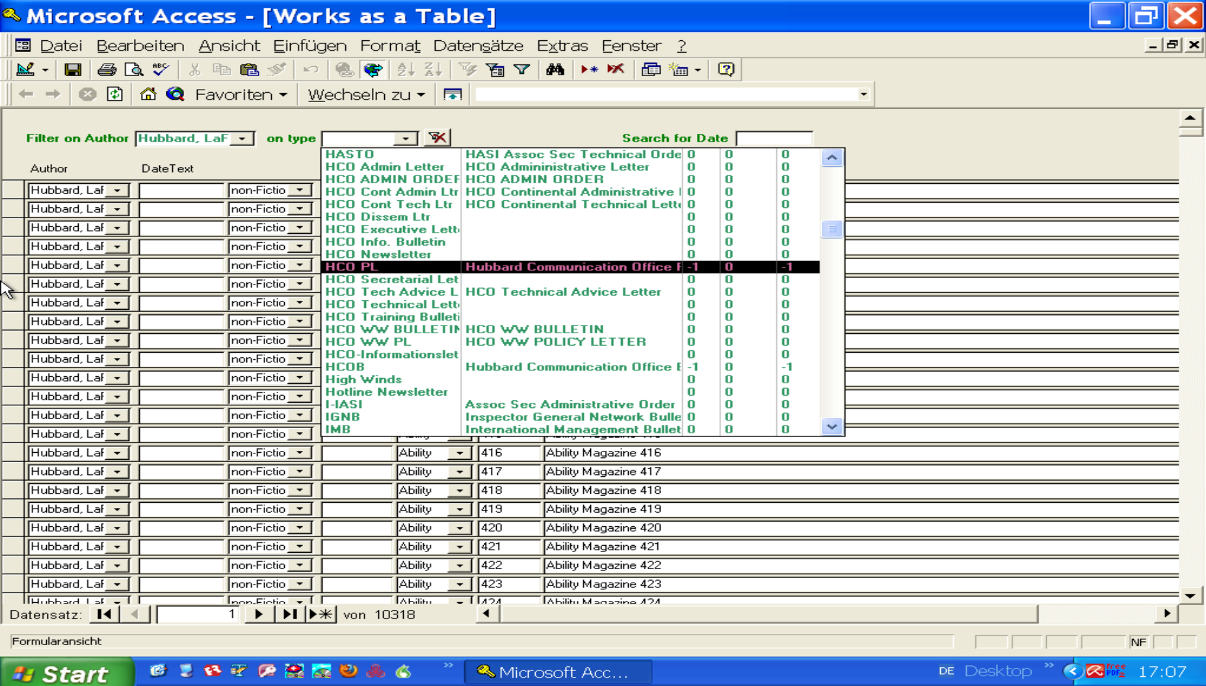
Filtered to Type: HCO PL

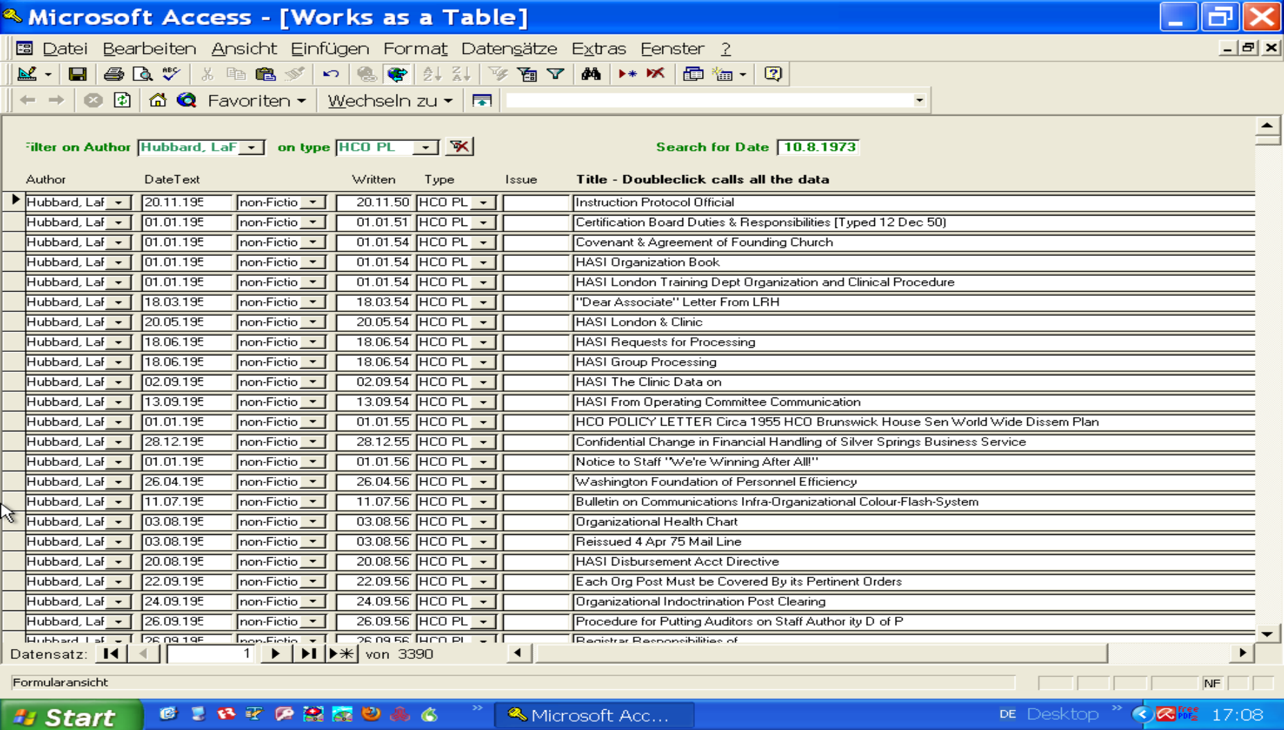
When a date is entered, you get all the records around this date:

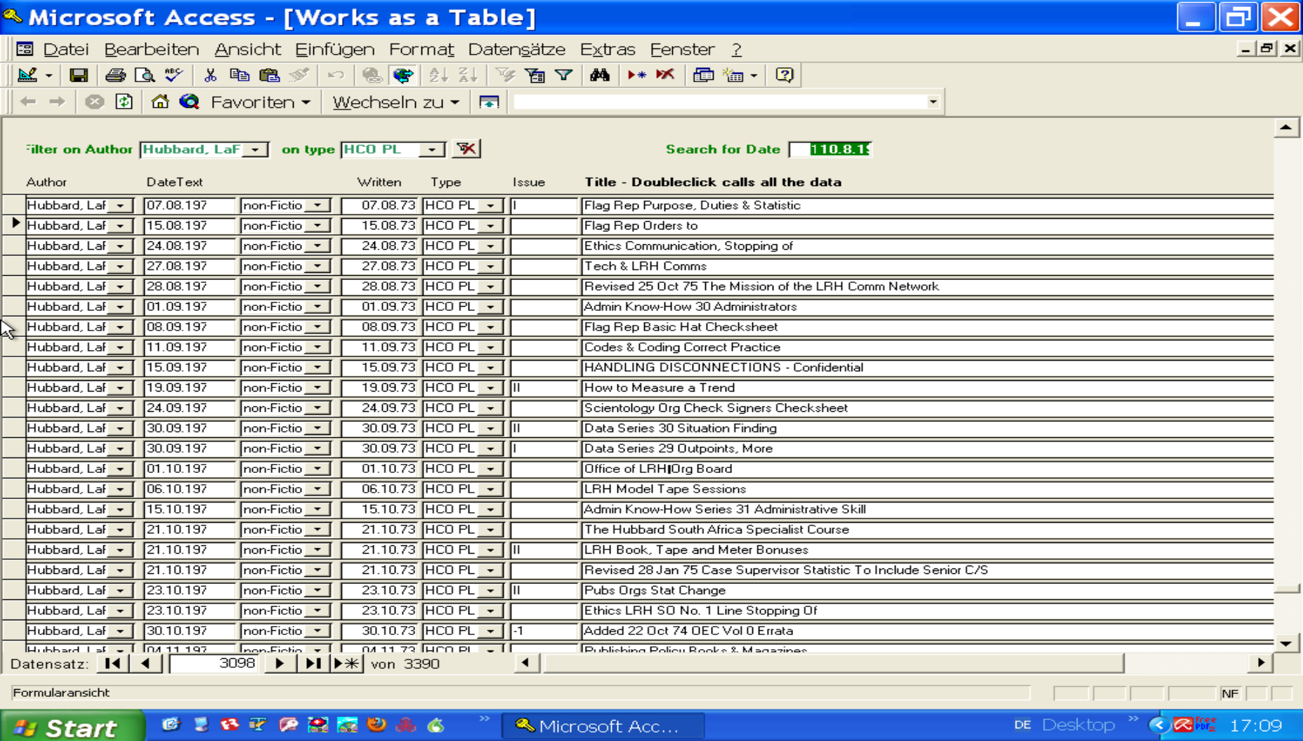
When you then click on the record (html-link for the chosen WORK), then the detail-view-page for Works should be loaded. In the old software that was accomplished by the Button on the right, perhaps we should additionally put also a button there:

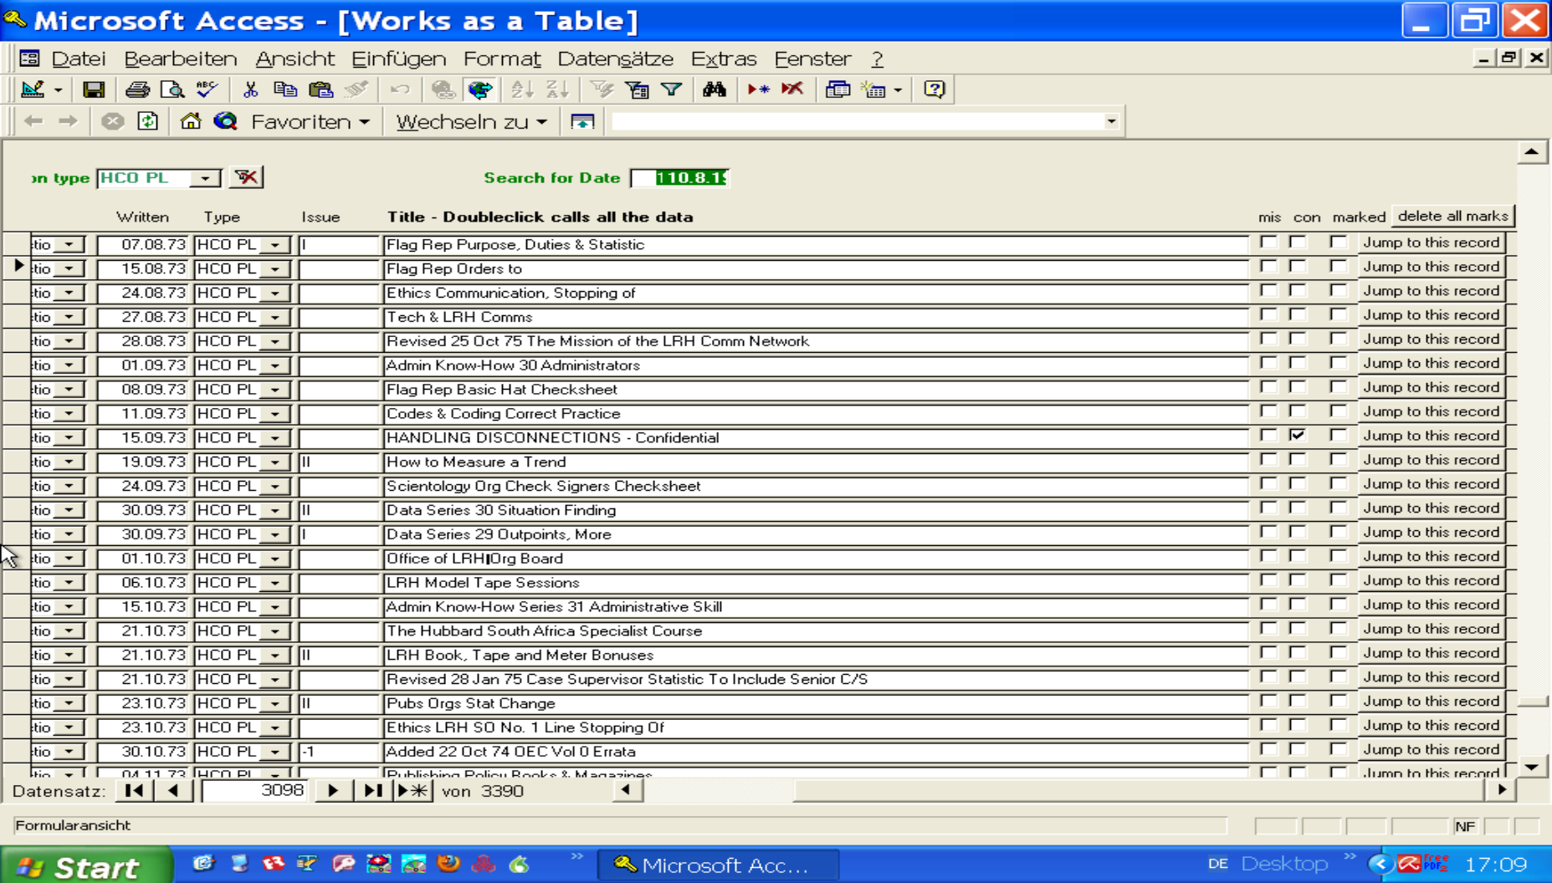
Now the Detail-view, which also has a few search fields (drop down) in the first 2 rows. But these we erase in our new Web-app, instead we output a header: the main data from chosen WORK: Title, date and type.

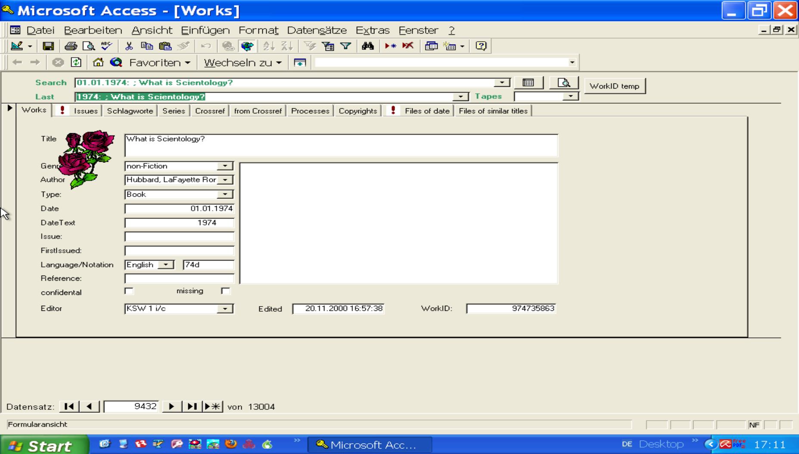
As there are so many data for one WORK-record, I have used TABs to put all the data on one screen.
In the beginning we use just 2 TABs:
- the WORK-detail view shown above
- The Issue list shown next:

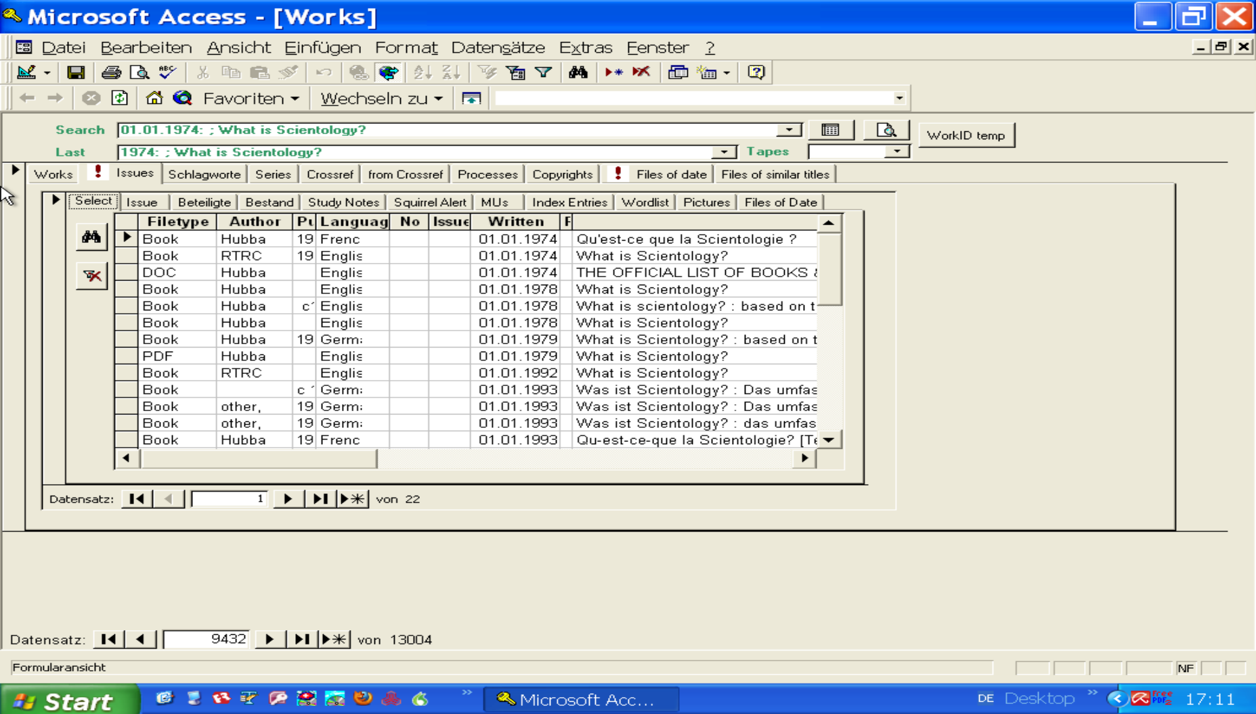
This above is the ISSUE-List of the chosen WORK: in relation by the field WorkID, which you can find in both Tables or PODS (which is just a modern name for a table).
Also this should be filtered by some fields like:
- Filetype
- Author
- Language
- Date (range)
Also in combination of these: perhaps give all 4 attributes and let the user choose a value from dropdown lists, and optional choose a date with since or until (later or earlier the entered date).
Then by click on a Button or by click on html-link in the title, you show the Issue-Detail-page:
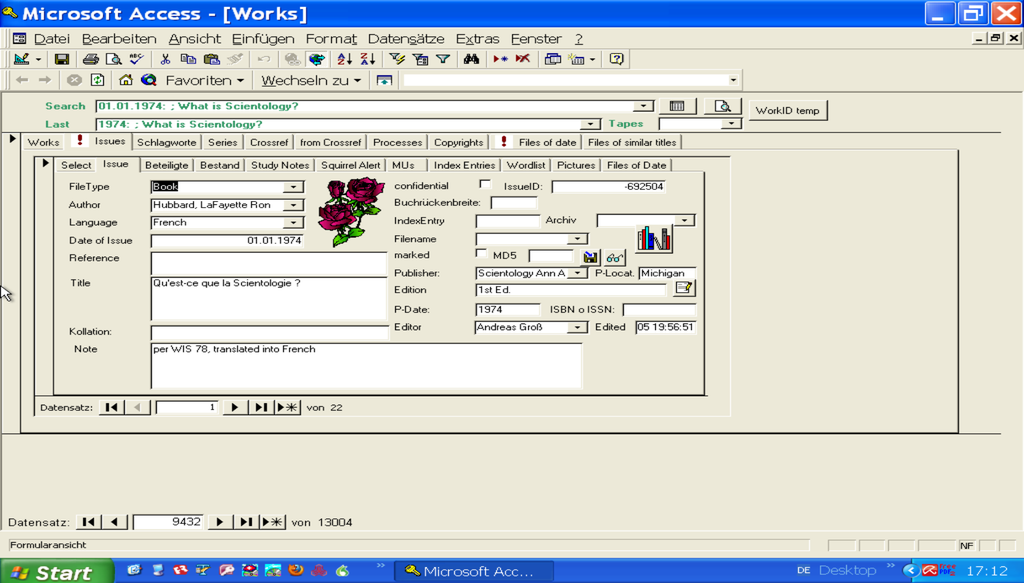

Milestone 2
Now some images of more tables, which we will include later:

Index
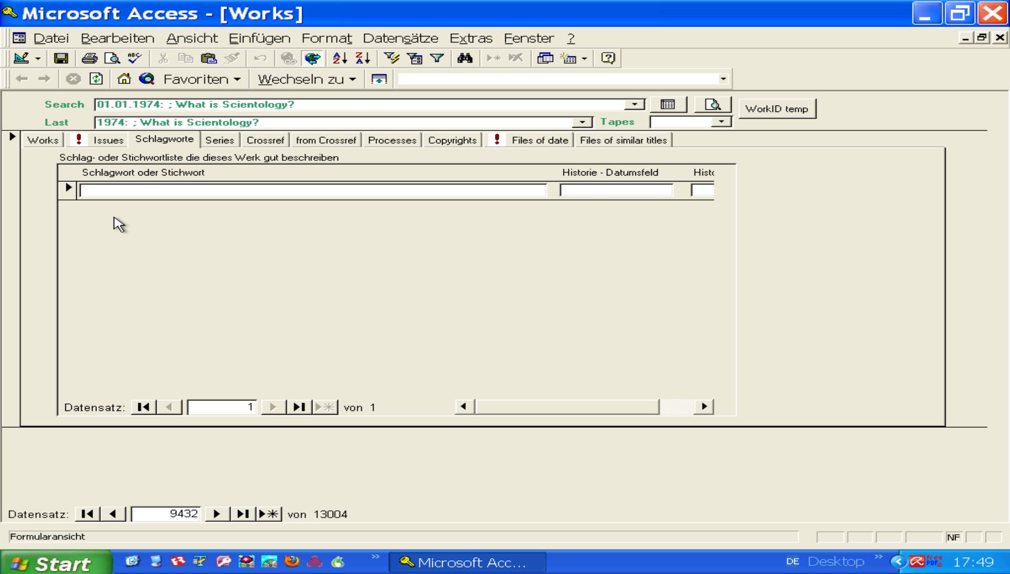
This is a keyword list for each Work. Contributors can add such keywords to a WORK, to be able to find again this Work later. If you sort these keywords alphabetically, you would end up with a full index on all Works on Scientology. An Index similar to the ones at the end of a book, where you will lookup a chapter you are interested in.

Series:
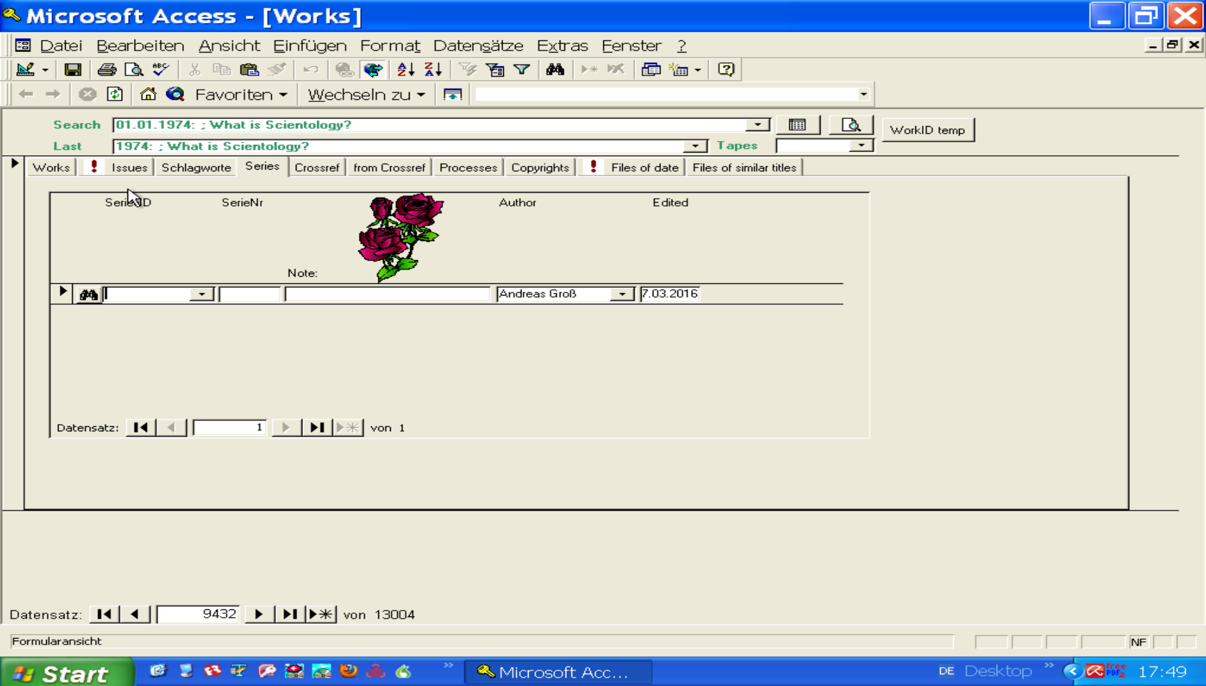
A lot of the works are grouped for sale to a „Series“: like a lecture series L. Ron Hubbard gave within a month consisting of 25 lectures, which are sold in one binder.
But a single work (one of the lecture) could be part of several different Series. So Series are a taxonomy, like Tags or Categories. You could also browse through the series (i.e. by date) and then lookup the list of all works, which belong to that chosen series.

A Serie could also be a course pack, consisting of hundreds of Works. In this case there is an order of the works within the course pack. So we should – as the image above shows – add the SeriesID and the SeriesNumber (telling us the sequence within the Series), and perhaps a note on this.

Cross-References
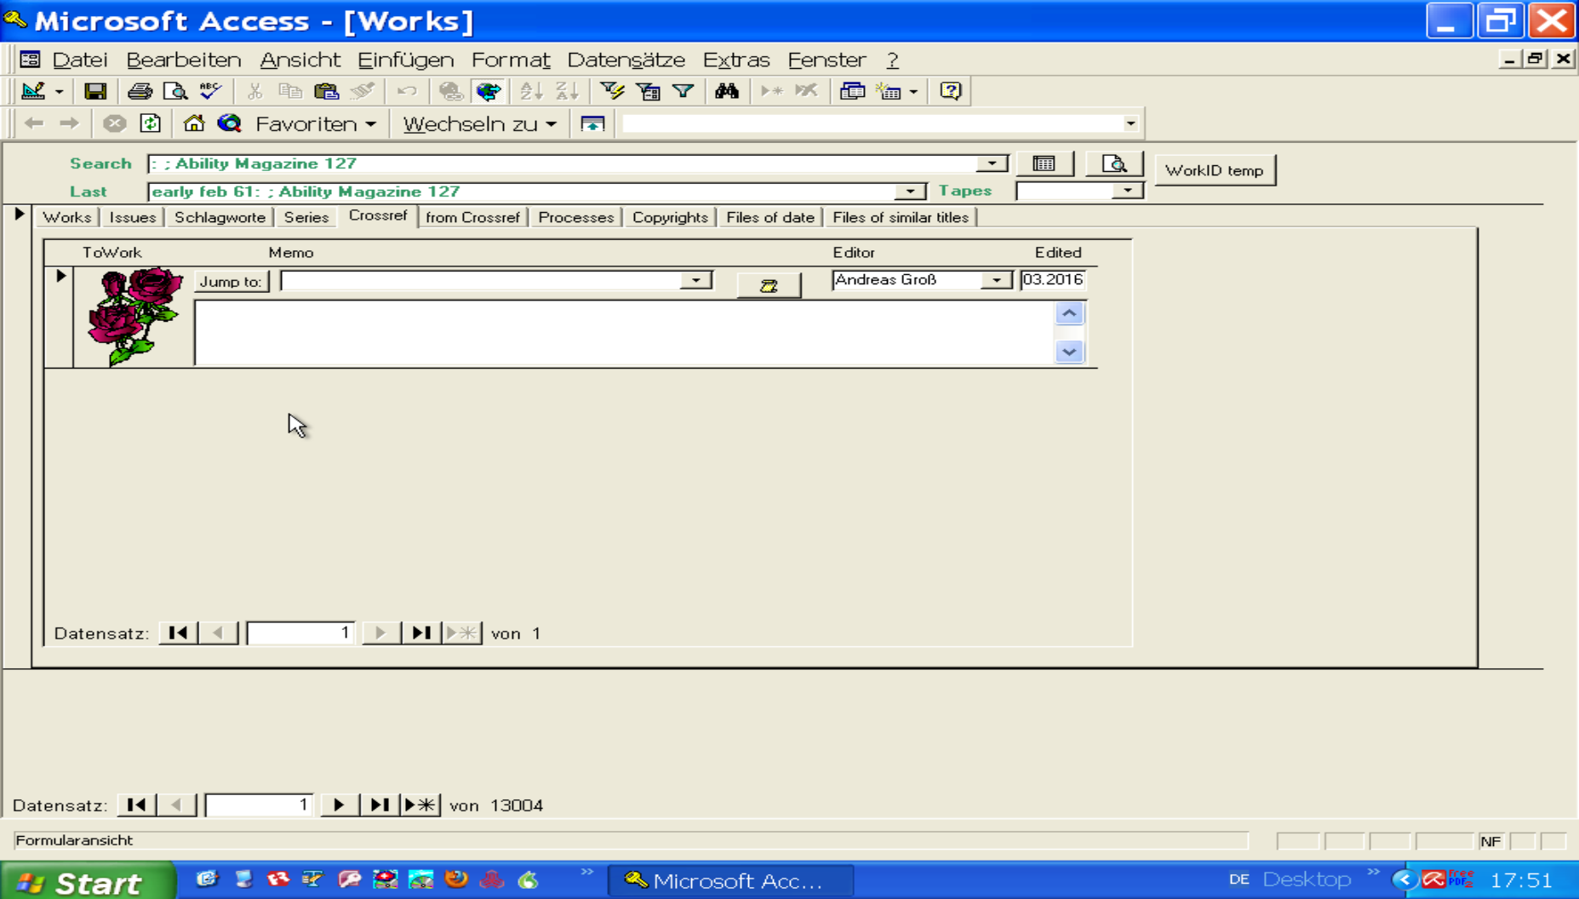
One work may be connected somehow to another one: i.e. in a Book one chapter consists of a transcript of a Lecture. So both works – Book and lecture – are related to each other. Here we can note down such a relation: we choose the 2nd work and add a comment about our observation: that might be „This article written 9 months later seems to be a revision of this work. Only changes are in the 3rd paragraph.“ - And one can easily jump by click from one work to the other and back again.

Processes
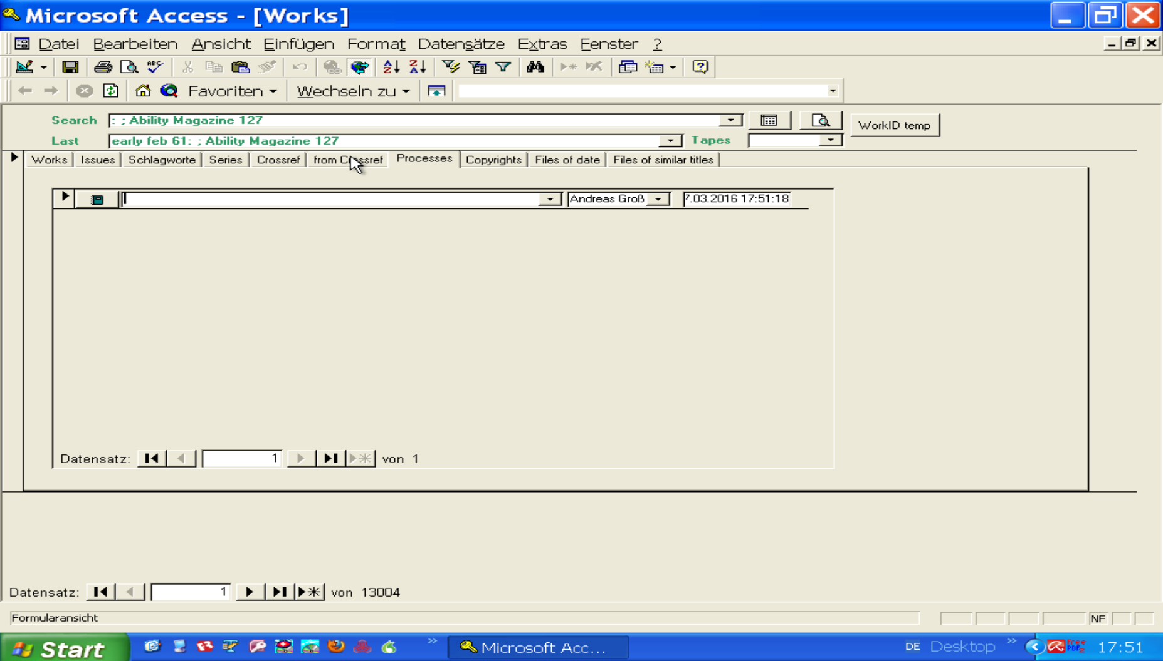
We have a table of Processes, which are described in the Works of L. Ron Hubbard. They have a n-to-m relation to each other: One Process may be decribed in several Works and in one Work there might be descriptions of several Processes. So we want to search for a certain Process i.e. by the purpose or name and then lookup all Works giving informations about the process.

And also the other way around:
We want to show all processes, described in one Work.
And with a mouse click we want to jump from a Work to the process and back to another Work describing this process. This helps in the study of them a lot.

Copyrights
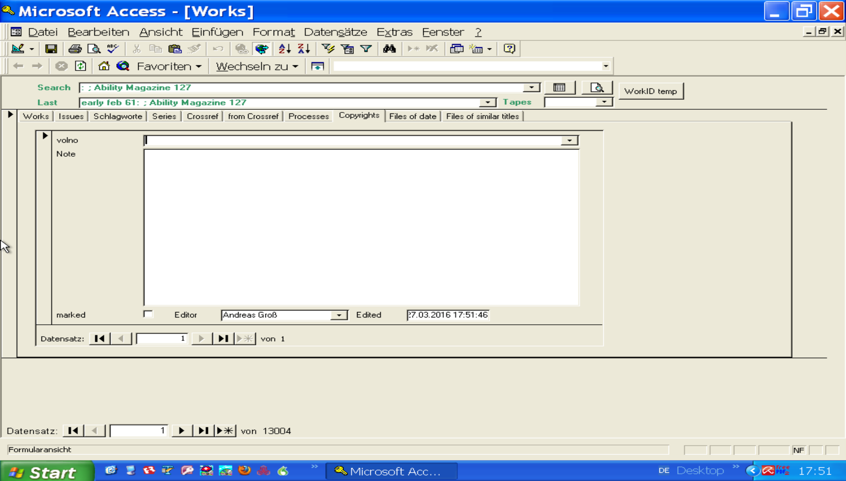
As the CoS (Church of Scientology) is claiming a monopoly on the Works of L. Ron Hubbard, which is not valid, we are interested in the copyright informations of each works. Because some went already in public domain, others are still valid (especially if you look at later works, after 1978, which are „based on the works of L. Ron Hubbard“ but not written by him). So we want to make such copyright information available and discussable. All our records can be commented upon by visitors. So we may gather more information through these comments.

File sharing among Scientologists
Up to now we only touched the surface of eBib: the Bibliography. But Scientologists are collecting the works of L. Ron Hubbard (and also secondary literatur about that) and that not only physically (paper books and tapes and CDs), but also in digitalized format: OCRed books, references, lectures etc. Most of them are be seen as illegal copyright infringement by the CoS.
In Switzerland it is even legal to share copies of copyrighted works among friends. But in the case of L. Ron Hubbard works, most of them went already in public domain.
Many Scientologists own a 2 TB hard drive full of such Works, even with millions of files in hundred thousands of folders. No one is able to find all he is looking for, as a life time is not enough to organize all these files. Luckily Scientologist believe in reinkarnation, so this task can be completed (joke). The task to organize all these files to get hold of one work or issue one is desparately looking for can only be accomplished by an organized effort, which is supported by eBib and is the purpose behind eBib.

As lots of Scientologists rename such files to put some bibliography data into the filename or path (like date, title, series, type, language), the collections between 2 friends can not easily be compared to find new „gold nuggets“.
There is a solution for this.

Files of the same Date
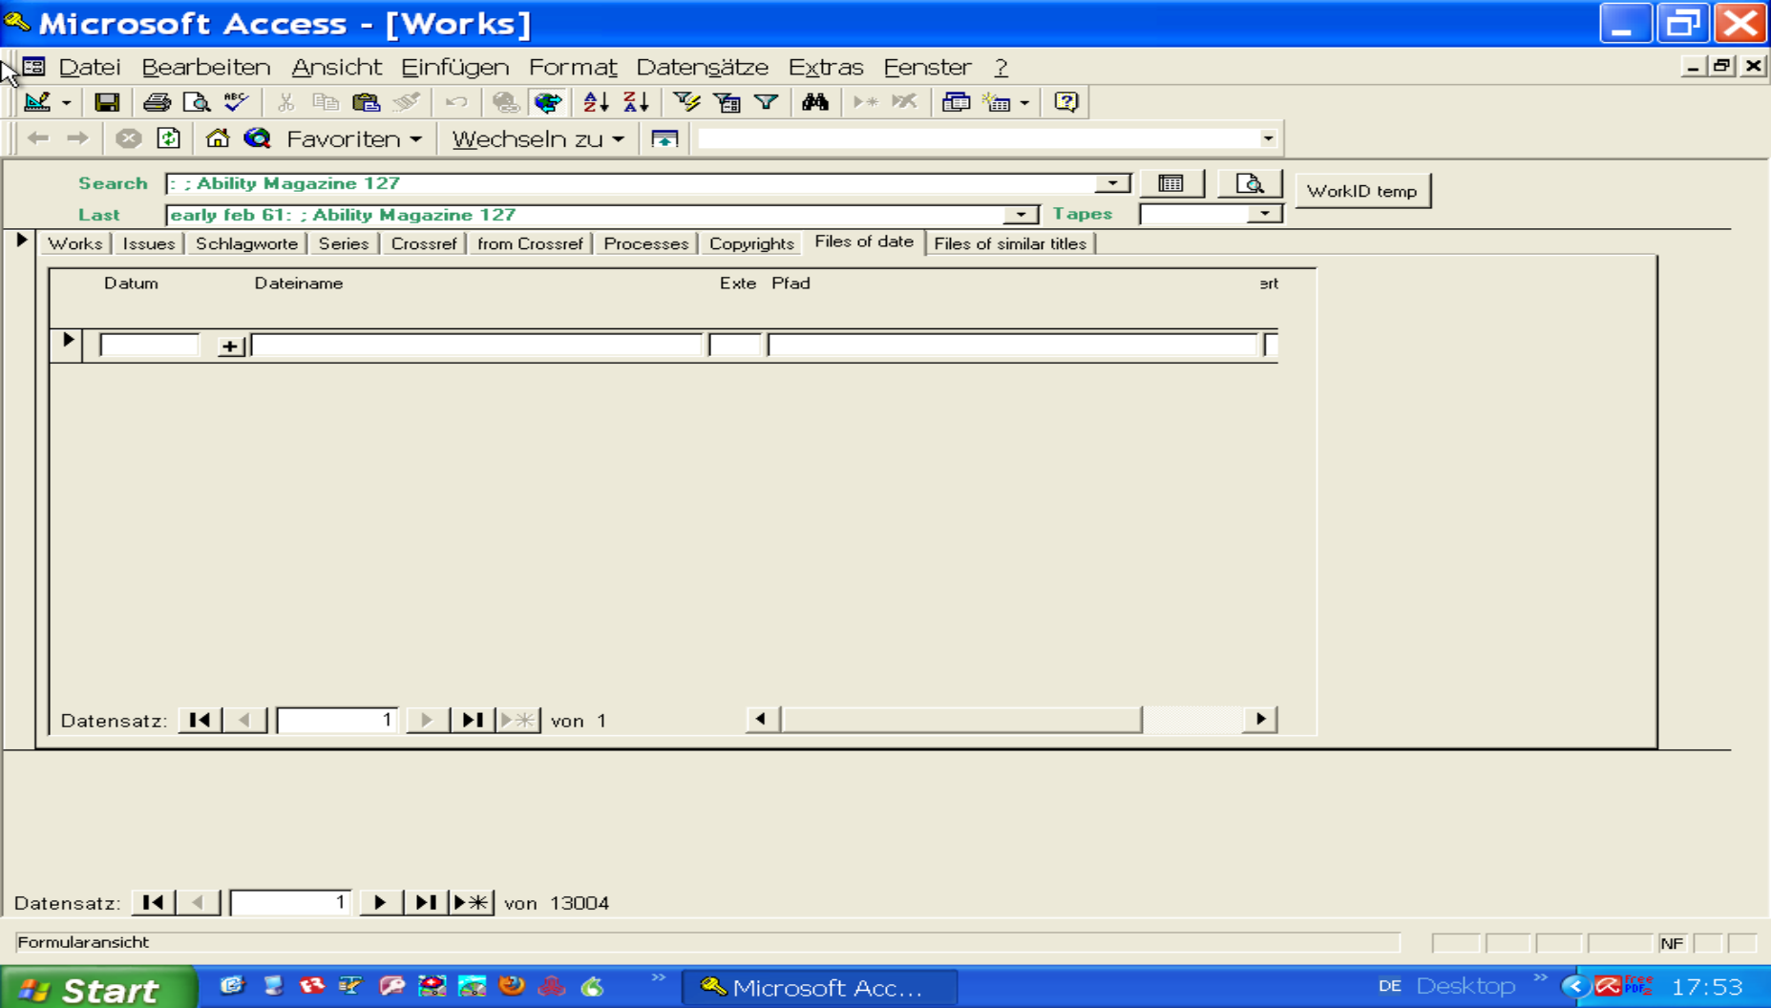
In this list, we show all files we have, with the same date as the Works-original-creation-date. This is necessary, as not all files have been integrated into eBib yet. Still some „gold nuggets“ can be found in the large file collection most of us own.

